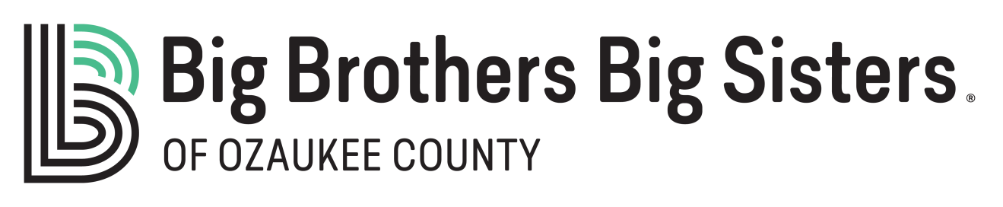
You invest. A child profits. It’s that simple. By making a donation in the form of stocks, bonds, mutual funds or other appreciated securities, you are making an investment in the future of children in your community.
As a donor, you are entitled to take a charitable deduction for the full fair-market value of appreciated securities held longer than one year, and you usually avoid paying the capital gains tax that would be due if you sold the securities.
Donating Stock or Bonds Held By a Bank or Broker
If your equities are currently held at a bank or in a brokerage account, simply send a letter of instruction to your broker or banker with a full description of the securities and your gift's intended purpose. Securities can be sent electronically using the following transmittal instructions:
Robert W. Baird & Co
Big Brothers Big Sisters of Ozaukee
Account #7519-9585 DTC #0547
For more information, please contact Michael Ratkovich at Baird North Shore at (262) 240-3500. Please advise us of your gift by contacting our Executive Director, Nicole Bulow, at (262) 377-0784 or by email at nicoleb@bbbsoz.org.
Effective Date and Value of Your Gift
Your gift of stock or publicly traded securities will be valued based on the mean market price of the securities on the gift date. We will provide you with a receipt for your tax records. Big Brothers Big Sisters determines your gift date according to the following guidelines:
- By mail, it is the later of the postmark dates of your separately mailed stock certificates and stock powers.
- By electronic transfer, it is the date that the securities enter Big Brothers Big Sisters’ account.
- By hand, it is the date that a Big Brothers Big Sisters' employee receives the stock certificates and stock powers of attorney.
- By reregistering securities in Big Brothers Big Sisters' name yourself, it is the date on the new certificates (this method takes the longest).

